
ADP470S Programming Assignment Report

Faculty of Informatics & Design
Advanced Diploma in ICT
Applications Development Practice 4

Thabiso Matsaba
Student No. 20296006
Lecturer: T. Makhurane
9 October 2026

Table of Contents
1. Introduction 3
2. Part A: Recursive algorithms 3
3. Part B: Searching and sorting 4
4. Part C: Elementary data structures 5
5. Part D: Binary search tree 5
6. Part E: Graphs 6
7. Reflection on theory and practice 7
8. References 7

1. Introduction
This report explains how I built the five parts of the assignment, gives the Big-O analysis for each, and reflects on where the results on my laptop matched the theory and where they did not. Everything is written in Java. Each part is its own class with a static run() method, and Main calls them in order, so one run of the program produces all the output quoted here. The source code is submitted separately.
All numbers in this report come from a single run of java Main in IntelliJ IDEA on JDK 21. Where a figure is calculated from a formula and not measured, I say so.
Part | Class | What it contains | Demonstration
A | PartA_RecursiveAlgorithms | Factorial and Fibonacci, recursive and iterative | n = 10, then a call count for n = 30
B | PartB_SearchingSorting | Selection, quick and heap sort; binary search | Three timed runs on 1,000 integers
C | PartC_DataStructures | Singly linked list, array stack, circular queue | String reversal and a bank queue
D | PartD_Trees | Binary search tree, traversals, height() | Insert 7 keys, delete 3
E | PartE_Graphs | Adjacency matrix, DFS, BFS, shortest path | 8-city transport network

2. Part A: Recursive algorithms
Design
Each recursive method has a base case (n is 0 or 1) and throws an IllegalArgumentException for negative input. I wrote an iterative version of each so the two could be compared on the same input. The return type is long because 13! is already too big for an int.
To compare the work done, fibonacciRecursive increments a static counter on every call and fibonacciIterative increments one on every loop pass. The method demonstrateCallCounts(30) resets both counters, runs each version and prints the totals.
Complexity
Algorithm | Time | Space | Reason
Recursive factorial | O(n) | O(n) | n nested calls on the call stack
Iterative factorial | O(n) | O(1) | One loop and one running total
Recursive Fibonacci | O(2ⁿ) | O(n) | Two calls per level, stack depth n
Iterative Fibonacci | O(n) | O(1) | Only the previous two values are kept

The two factorial versions do the same number of multiplications. The recursive one also uses a stack frame per call, so it can overflow the stack for very large n while the loop cannot. Fibonacci is different because each call makes two more calls and the same values are worked out again and again.
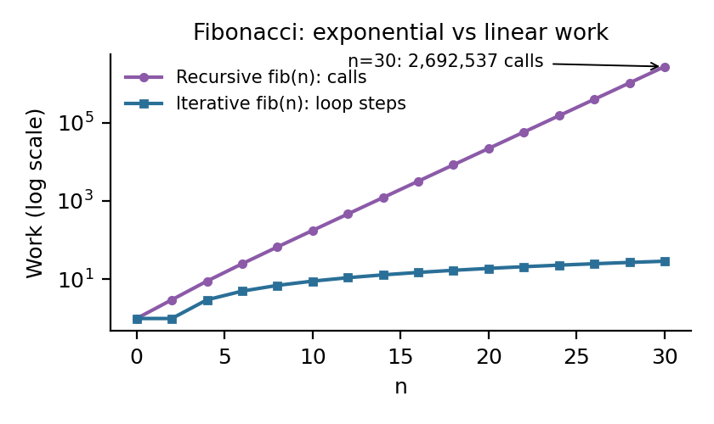  Figure 1: Calls made by recursive Fibonacci against loop steps (calculated from 2F(n+1) − 1). | 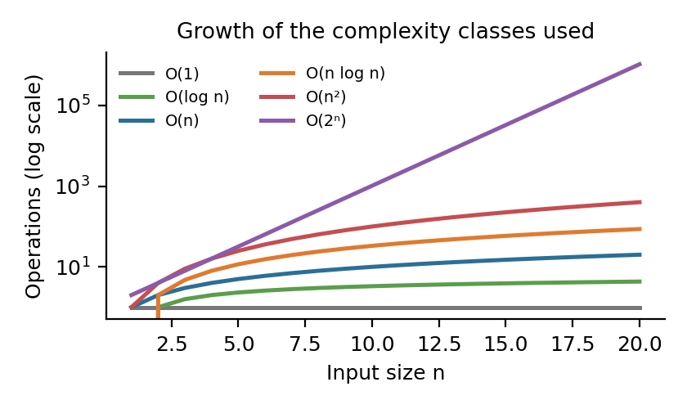  Figure 2: Growth of the complexity classes used in this report.
Reflection
For n = 10 both Fibonacci versions printed 55 instantly, and from that output alone I could not tell them apart. The counter changed that. For n = 30 the recursive version made 2,692,537 calls and the loop made 29 steps, for the same answer of 832040. Even so, I noticed no pause when the program ran, so on a modern laptop an O(2ⁿ) algorithm can look acceptable at a small n. The count grows by about 1.6 times for each extra n, which puts n = 50 at roughly 40 billion calls. What I took from this is that timing a small input can hide a bad algorithm, and counting operations shows it.
One small surprise was the output format. String.format("%,d") printed 2 692 537 with spaces on my machine because Windows is set to South African regional settings. The value is the same, only the separator differs.

3. Part B: Searching and sorting
Design
Selection sort is iterative and sorts in place. Quick sort uses the Lomuto partition with the last element as the pivot. Heap sort builds a max-heap from the bottom up, then repeatedly swaps the root to the end and restores the heap. Binary search is written both iteratively and recursively, and both calculate the middle as left + (right − left) / 2 so the sum cannot overflow.
The experiment is in runTimingExperiment. It generates one array of 1,000 random integers between 0 and 9999. In each of three runs every algorithm gets its own copy of that array, so none of them receives data that another has already sorted. Each sort is timed with System.nanoTime() and the result is converted to milliseconds. After the runs the program searches the sorted array for a value that is present and for 10000, which cannot be present.
Complexity
Algorithm | Best | Average | Worst | Extra space
Selection sort | O(n²) | O(n²) | O(n²) | O(1)
Quick sort | O(n log n) | O(n log n) | O(n²) | O(log n) stack, O(n) worst
Heap sort | O(n log n) | O(n log n) | O(n log n) | O(1)
Binary search | O(1) | O(log n) | O(log n) | O(1) iterative, O(log n) recursive
Experimental results
Run | Selection sort | Quick sort | Heap sort
Run 1 | 13.708 ms | 1.817 ms | 2.328 ms
Run 2 | 2.750 ms | 0.357 ms | 0.631 ms
Run 3 | 5.683 ms | 0.201 ms | 0.385 ms
Average | 7.380 ms | 0.792 ms | 1.114 ms
Relative to quick sort | 9.3 times | 1.0 | 1.4 times

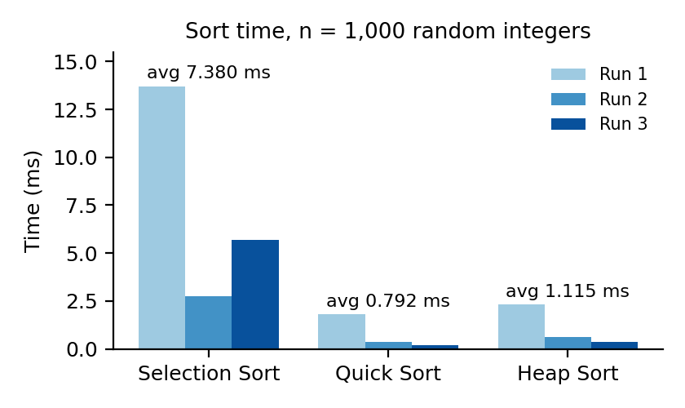  Figure 3: Measured sort times for the three runs. | 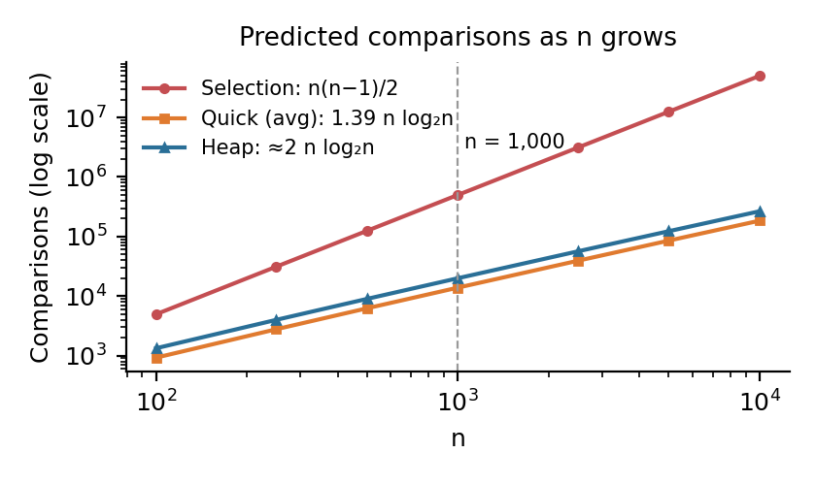  Figure 4: Predicted comparisons as n grows (calculated, not measured).
The ranking matches the theory in every run: selection sort was slowest, heap sort second and quick sort fastest. Both binary searches found the present value 4992 at index 500 and returned −1 for 10000. On 1,000 elements that takes at most 10 comparisons, because 2¹⁰ is 1,024.
Reflection
The size of the gap did not match what I calculated beforehand. Selection sort makes n(n − 1)/2 comparisons, which is 499,500 for n = 1,000. Quick sort averages about 1.39 n log₂ n, close to 14,000. That is a ratio of about 36, yet selection sort was only 9.3 times slower on average. Big-O counts comparisons and ignores how cheap each one is. Selection sort's inner loop is a single comparison on neighbouring array elements, so each step costs very little, and at n = 1,000 that hides part of the difference. Figure 4 shows the gap widening as n grows, so I would expect a much larger ratio at 100,000 elements. I did not test that size.
The timings were also far less steady than I expected. Run 1 took 13.708 ms for selection sort and run 2 took 2.750 ms on the same data. The first run includes the time the JVM spends compiling the methods (JIT warm-up), so it measures Java starting up as much as the algorithm. Run 3 was then slower than run 2 for selection sort (5.683 ms against 2.750 ms) while quick sort and heap sort got faster. I cannot explain that from the algorithm. It is most likely other activity on the laptop during that fraction of a second. Three runs is a small sample, and the average of 7.380 ms is pulled up by run 1. If I repeated the experiment, I would discard a few warm-up runs and average over many more.
Heap sort was only 1.4 times slower than quick sort, which is closer than I expected. Its advantage does not show in this test: it stays O(n log n) on every input, whereas my quick sort with a last-element pivot would drop to O(n²) on an array that is already sorted. With random data that case never came up.

4. Part C: Elementary data structures
Design
None of the three structures uses a java.util collection. The singly linked list keeps a head and a tail reference. Insert links the new node after the tail, so it does not need to walk the list. Delete has to update the tail when the last node is removed and clear it when the list becomes empty. The stack is a fixed array with a top index that starts at −1, and push and pop throw an exception when the stack is full or empty. The circular queue keeps front, rear and a size counter, and moves each index with (index + 1) % capacity so that slots freed at the front are used again.
Complexity and tests
Structure | Operation | Time | Test and result
Singly linked list | Insert at end | O(1) | Insert 10, 20, 30, 40
Singly linked list | Search, delete | O(n) | Delete 30, delete head 10, delete missing 99 (list unchanged)
Array stack | Push, pop, peek | O(1) | "Hello World!" reversed to "!dlroW olleH"
Circular queue | Enqueue, dequeue, peek | O(1) | 101 and 102 served first, then 103 to 107 in order

Each structure uses O(n) space for n stored items. The stack shows last in, first out: the characters come back in reverse order. The queue shows first in, first out: customers are served in the order they arrived.
Reflection
The queue test did not do what I had planned. I gave the queue a capacity of 5 and meant customer 107 to be turned away, and the comment in the code still says so. The output shows 107 being served. By the time 107 arrives two customers have already been served, so only four of the five slots are in use and the enqueue succeeds. This means my run never prints the "Queue is full" message, although the isFull() check is in the code. The test does show the wrap-around working: 106 and 107 are stored in slots 0 and 1, which 101 and 102 had left. The empty-queue case is tested and prints "Error: Queue is empty".
The tail pointer made insert O(1) but it also made delete harder to get right, because there are now two references to keep correct. Deleting the head of a one-item list and deleting the last node are both cases where a stale tail would break the next insert. The simpler version without a tail has none of these cases but walks the whole list on every insert.

5. Part D: Binary search tree
Design
The tree has public insert, search and delete methods that call recursive helpers. A key that is already in the tree is ignored. Delete handles three cases: a leaf is removed, a node with one child is replaced by that child, and a node with two children takes the key of its in-order successor (the smallest key in its right subtree), which is then deleted from that subtree. I added height(), which returns the number of nodes on the longest path from the root to a leaf.
Complexity and tests
Operation | Average | Worst | Test | Output
Insert | O(log n) | O(n) | 50, 30, 20, 40, 70, 60, 80 | Height 3
Search | O(log n) | O(n) | 40 and 90 | true and false
Delete | O(log n) | O(n) | 20 (leaf), 30 (one child), 50 (two children) | Height 3 after each
Traversals, height() | O(n) | O(n) | Full tree | In-order: 20 30 40 50 60 70 80

Insert, search and delete each follow one path down from the root, so their cost is the height of the tree. When keys arrive in random order the height is close to log₂ n. When they arrive in sorted order every node becomes a right child, the tree is a chain, and the height is n. Figure 5 plots these two cases.
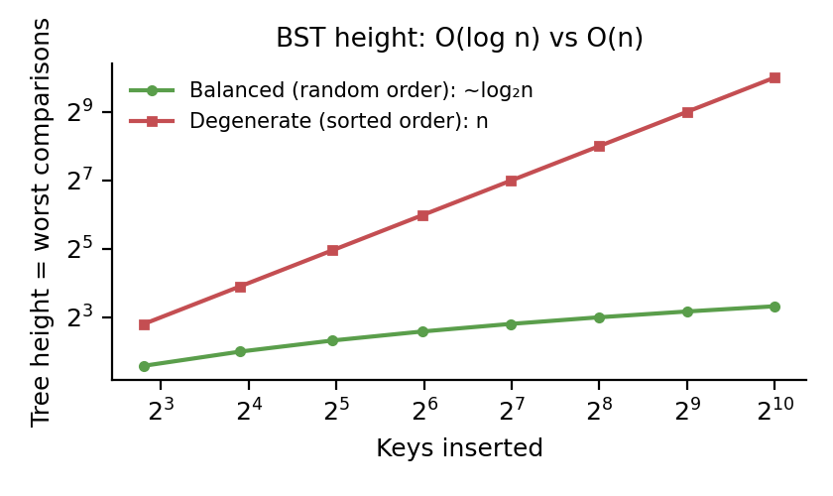  Figure 5: Height of a balanced and a chain-shaped BST (calculated). | 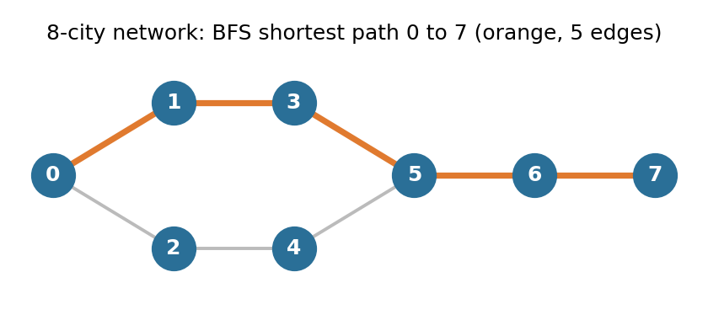  Figure 6: The Part E network with the BFS shortest path.
Reflection
My seven keys were inserted in an order that gives a perfectly balanced tree, so the program printed a height of 3, which is the lowest possible for 7 nodes. The height was still 3 after all three deletions, which I did not expect. Deleting 50 moved 60 up to the root, and the path 60, 70, 80 is still three nodes long. The pre-order output 50 30 20 40 70 60 80 was useful for checking the shape, because it lists each parent before its children.
The weakness of my test is that it only shows the good case. I did not insert sorted keys, so the O(n) worst case in the table and in Figure 5 is from the theory and not from my output. Because insert and height() are recursive, a chain of many thousands of keys could also overflow the call stack, which Big-O does not show. A self-balancing tree such as an AVL tree avoids the chain, at the cost of rotations on insert and delete.

6. Part E: Graphs
Design
The network is undirected and is stored in a V × V adjacency matrix. addEdge sets both [a][b] and [b][a]. DFS is recursive and marks vertices in a visited array. BFS uses a queue. shortestPath is BFS with a parent array: when a vertex is first reached, the vertex it was reached from is recorded. The route is then read backwards from the destination onto a stack and popped, so it prints from source to destination with the number of edges. BFS visits vertices in order of distance from the start, so the first time it reaches a city is by a route with the fewest edges.
Complexity and results
Algorithm | Time with matrix | Time with list | Space | Output from city 0
DFS (recursive) | O(V²) | O(V + E) | O(V) | 0 1 3 5 4 2 6 7
BFS (queue) | O(V²) | O(V + E) | O(V) | 0 1 2 3 4 5 6 7
Shortest path | O(V²) | O(V + E) | O(V) | 0 → 1 → 3 → 5 → 6 → 7 (5 edges)

The matrix itself takes O(V²) space. Checking whether two cities are connected is O(1), but finding a city's neighbours means scanning a whole row of V entries, which is why all three algorithms are O(V²) however few edges there are.
Reflection
The DFS order looked wrong to me at first. It visits 4 and then 2 after 5, which is backwards compared with how I added the edges. It is correct: DFS goes as deep as it can along 0, 1, 3, 5, and from 5 the lowest-numbered unvisited neighbour is 4, which leads back to 2. BFS gives 0 to 7 in numerical order only because of how I numbered the cities.
There are two routes of equal length from city 0 to city 5, one through 1 and 3 and one through 2 and 4. The program reports the one through 1 because the loop scans neighbours from the lowest index. So "the" shortest path is really one of two, and which one is printed depends on the vertex numbering. Two things are missing from my version. If there is no route, the method still prints the destination on its own with 0 edges, where it should say that no path exists. And every edge counts as one hop, so a short road and a long road are treated the same. Real distances would need edge weights and Dijkstra's algorithm. My network has 8 edges out of a possible 28, so most of the matrix is zeros, and an adjacency list would suit a larger network better.

7. Reflection on theory and practice
Big-O predicted the order of the results correctly every time. Selection sort was always slowest, the recursive Fibonacci did far more work than the loop, and the tree and graph outputs matched what the definitions say. What it did not predict was the size of the differences. A calculated ratio of about 36 between selection sort and quick sort came out as 9.3, and one run of the same code on the same data took five times longer than the next.
The second thing I learned is that my tests mostly showed the good cases. The BST was balanced, the quick sort input was random, the queue never filled and the graph was connected. The worst cases in my tables are correct, but they come from the theory. A better test plan would include sorted input for the BST and quick sort, a sixth customer for the queue and two cities with no route between them.
The limits of the experiment are one laptop, three runs and one input size. The numbers are enough to compare the three sorts with each other. They are not enough to say how fast any of them is in general.

8. References
Cormen, T. H., Leiserson, C. E., Rivest, R. L., & Stein, C. (2009). Introduction to algorithms (3rd ed.). MIT Press.
Lafore, R. (2002). Data structures and algorithms in Java (2nd ed.). Sams Publishing.
Oracle. (2024). Java Platform, Standard Edition documentation. https://docs.oracle.com/en/java/
Sedgewick, R., & Wayne, K. (2011). Algorithms (4th ed.). Addison-Wesley Professional.

